Online Add Process with Instructor Permissions

(Registration Stickers)

Please read before adding!

Online Add Procedure: Please use the permission number the instructor has given you and follow the steps below to register for your section. If you have met all the pre-requisites, have no time conflicts, have not had excessive repeats of the course, and/or do not owe fees, you will be added to the section. If you have questions about pre-requisites, consult the class schedule, school catalog, or speak with a counselor. Before adding the new section, drop the classes you are no longer taking. If you have a time conflict (e.g. a class you are enrolled in overlaps by one minute or more with a course you are trying to add), you will not be able to add the new class and no one is able to override that requirement.

Note: the permission number only works for one student.

- Go to: http://myecc.elcamino.edu.
- Login in with your username and password.
- Under WebAdvisor, click on “Registration– Add & Drop”.
- Click on “Online Add with Faculty Permission”.
- You will see the screen below and be asked to enter the two sets of numbers on the sticker.

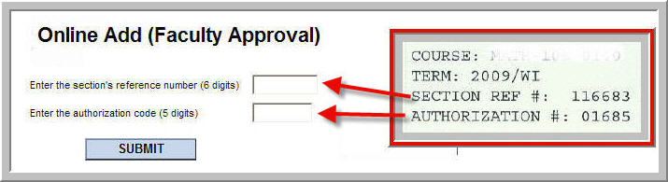

- Click on the “SUBMIT” button.
- Once you successfully add the section, use the “Make a Payment” link in the “Make Payment & Account” section and pay the amount due.

You are now added to the class and you do not need to go to the Admissions Office. If you encounter problems adding online, write down the error message you receive, if any, and please take the permission slip to the Admissions Office. If you cannot come to campus, please email your instructor with the error information.

Deadline to Add: You will not be able to add your class before the semester starts or after the add deadline. The deadline for regular term courses is published in the class schedule. Ask your instructor for the short term add deadline or you may examine the Short Term Class Calendar available in the Admissions Office or in the Academic Division offices.

